**Project Development Phase**

**SPRINT 1**

|  |  |
| --- | --- |
| **Date** | **6th November 2022** |
| **Team ID** | **PNT2022TMID28767** |
| **Project Name** | **IoT Enabled Smart Farming Application** |
| **Team Members** | **Chithra Burri**  **Chintham Ruthesh Premkanth**  **Vinay K**  **Sk. Sohail** |

**Configuration:**

An account has been created on the required platforms (IBM Cloud, IBM Watson, Node Red, MIT App Inventor)

**IBM Cloud:**

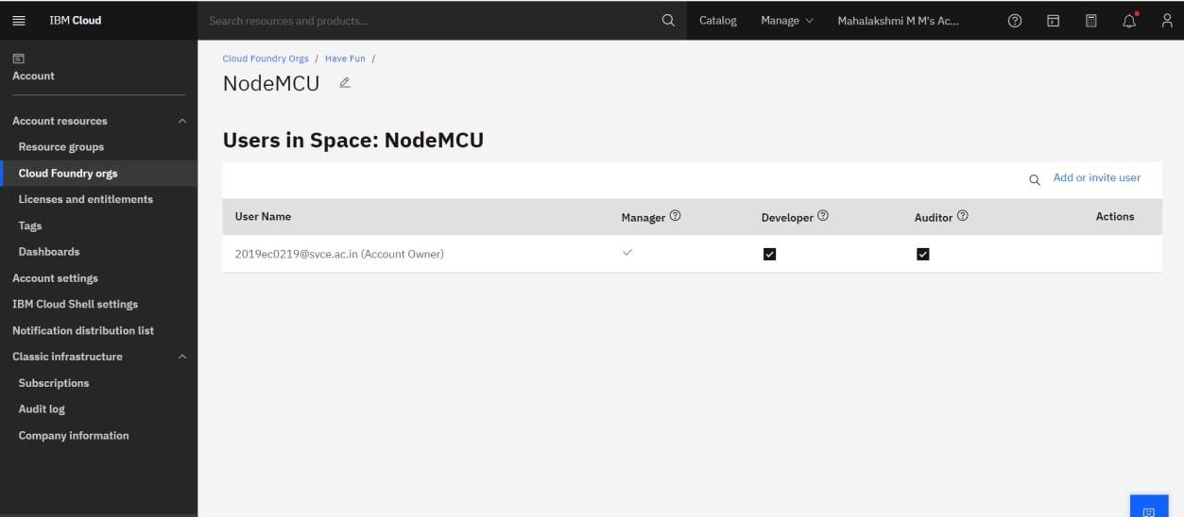

**IBM Watson:**

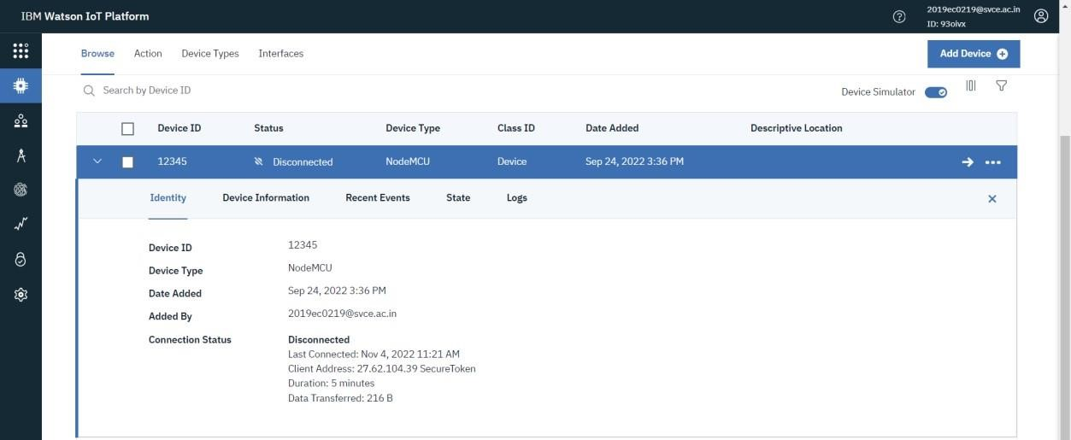

**Node-Red:**

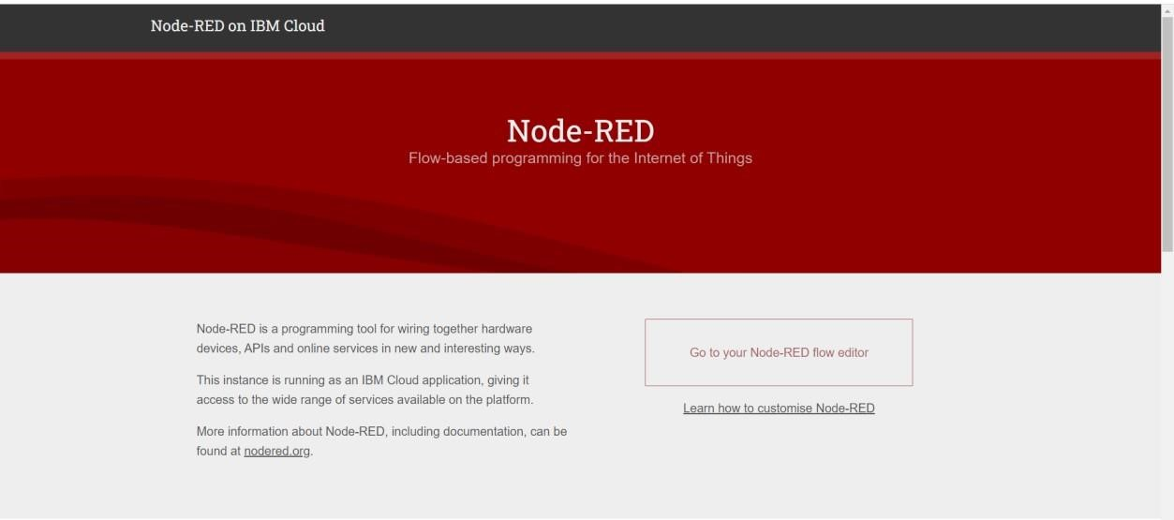

**MIT App Inventor:**

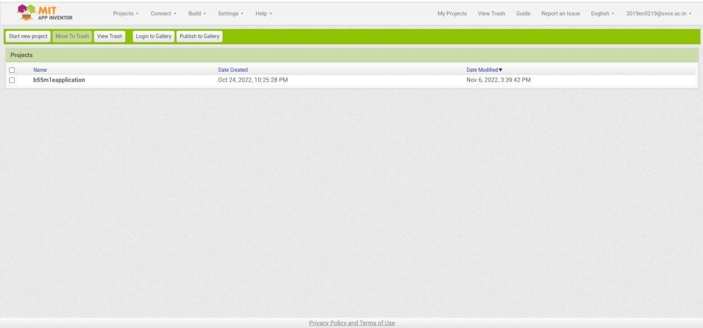

**Simulation:**

**Program:**

#include <Adafruit_Sensor.h>

#include <DHT.h>

#include <DHT_U.h>

#define DHTPIN 4

#define DHTTYPE DHT22

DHT_Unified dht(DHTPIN, DHTTYPE); uint32_t delayMS; void setup() { **Serial**.begin(960

0); // Initialize device.

dht.begin();

**Serial**.println(F("DHTxx Unified Sensor Example")); sensor_t sensor; dht.temperature().getSensor(&sensor);

**Serial**.println(F("------------------------------------"));

**Serial**.println(F("Temperature Sensor"));

**Serial**.print(sensor.resolution);

**Serial**.println(F("°C"));

**Serial**.println(F("------------------------------------"));

dht.humidity().getSensor(&sensor); **Serial**.println(F("Humidity Sensor"));

**Serial**.print(sensor.resolution);

**Serial**.println(F("%"));

**Serial**.println(F("------------------------------------")); delayMS = sensor.min_delay / 1000; } void loop() { delay(delayMS); sensors_event_t event; dht.temperature().getEvent(&event); if (isnan(event.temperature)) {

**Serial**.println(F("Error reading temperature!"));

} else {

**Serial**.print(F("Temperature: "));

**Serial**.print(event.temperature);

**Serial**.println(F("°C")); } dht.humidity().getEvent(&event); if (isnan(event.relative_humidity)) {

**Serial**.println(F("Error reading humidity!"));

} else {

**Serial**.print(F("Humidity: "));

**Serial**.print(event.relative_humidity);

**Serial**.println(F("%"));

}

}

**OUTPUT:**

